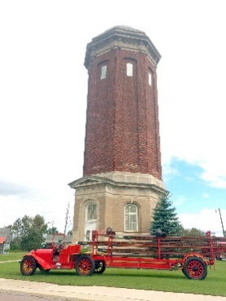**Schoolcraft County Historical Society**

**P.O. Box 284, Manistique, Michigan 49854**

[**schs1860@gmail.com**](mailto:schs1860@gmail.com) 906-286-4103

[**www.cityofManistique.org/schs**](http://www.cityofManistique.org/schs)

**@SCHistoricalSociety**

***The Schoolcraft County Historical Society*** is dedicated to the collection, cataloguing, preservation and displaying for the purpose of public awareness, artifacts, and information depicting the history of Schoolcraft County. The purpose of the Society is to discover, collect and preserve material which may help to establish or illustrate the history of Schoolcraft County, including its exploration, settlement, development, activities in peace and in war and its progress in population, wealth, education, arts, sciences, agriculture, manufacture, trade and transportation.

**Membership Benefits**

All members receive electronic newsletters, are encouraged to participate in monthly meetings, and receive Member discounts on many society services.

**Individual Annual** $20___ **Individual Lifetime** $200 ___**Student (HS or College**) $10____

**In Memory of**__________________________________________________________ $100

**New Museum** $____ **Urania Restoration Project** $____ **Renewing Member**? ____

Name______________________________________________________________________

Address____________________________________________________________________

Phone___________________________________Email______________________________

**Volunteer Opportunities! Please circle interests**

Community Events, Marketing, Social Media, Administrative, Fundraising, Pioneer Park Docent at Water Tower, Log Cabin, Post House, Research, Other_________________

**Mail** check to SCHS, P.O. Box 284, Manistique MI 49854 or **Donate via PayPal** link on our Facebook page or on our website at schs.cityofmanistique.org

Schoolcraft County Historical Society is a Michigan non-profit organization formed under the umbrella of the Schoolcraft County government.